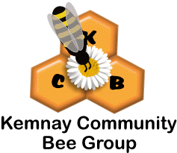
KCBG Membership Form 2024
Annual Fees
Club membership: Single/family - £20

Full Name _______________________________________________
Full Postal _______________________________________________
Address _______________________________________________
Postcode ______________________________________________
Telephone Number: __________________________________________
Email address: ____________________________________________
Beebase Registration No. (if known): ____________________________

Membership fee: £20 – please indicate
Paid online ……………… Paid cash at AGM……………….

- Full protective clothing must be worn at all times during hive visits.
- This includes Bee Veil, Bee Jacket and Trousers (or all in one Bee Suit).
- Bee Gloves and preferably Wellingtons (to protect ankles).

Funds will be used for improving and securing the site, purchasing tools, equipment, food and treatments as required, payment of visiting speaker fees, payment of Scottish Beekeepers Association affiliated membership fee and administration costs.

I give my consent to KCBG using my contact details to keep me informed about Group Activities.
Signed: ________________________________ Date: ___________________________
If returning by email just insert name.

Bank details for online payment:
Name of Account: Kemnay Community Bee Group
Sort Code: 83-23-12 Account No: 00204862
Please enter your surname as payment reference

